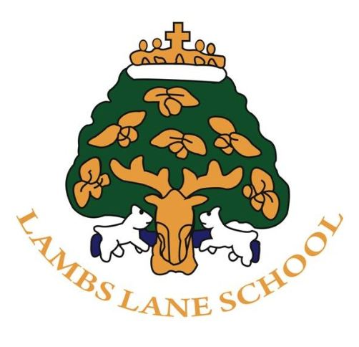

The Governing Body

The Governing Body is made up of parents, staff and local people working together as a team to provide support and direction to the school. The Governors have legal duties, powers and responsibilities for the efficient running and upkeep of the school.

Our aim is to promote the inclusive ethos of Lambs Lane recognising that there is more to education than academic standards.

We meet twice a term and work to the School Development Plan and monitor progress towards our objectives for the school. The Staffing, Finance & Premises and Pupil Matters committees also meet regularly. Lambs Lane Primary School, Full Governing Body can consist of 2 Parent Governors, 1 Headteacher, 1 Staff Governor, 1 Local Authority Governor and 7 Co-opted Governors.

 |  | Term Dates
Mr James Birtwistle (Chair) | Co-opted Governor | 14/07/22 to July 2025
Mr Mark Duffin (Deputy Chair) | Local Authority | 01/02/24 to Sept 2027
Miss Julie Audoire | Co-opted Governor | 14/07/22 to July 2025
Mrs Clare Pilgrim | Co-opted Governor | 01/02/24 to Jan 2027
Mrs Rachel Richards | Co-opted Governor | 26/02/24 to Feb 2027
Anisha Esmail | Co-opted Governor | 11/09/23 to Sept 2026
Leah Hart | Co-opted Governor | 10/09/24 to Sept 2027
VACANCY | Co-opted Governor
Mr Harpreet Puri | Parent Elected | 15/08/22 to Mar 2025
VACANCY | Parent Elected
Mr Alex Leaver | Staff Governor | 29/09/20 to 29/09/23
Mrs Sharon Finn | Head | Ongoing
 | Clerk | Ongoing
Mrs Lisa Lainsbury | Associated Governor | Ongoing
TBC | Associated Governor | Ongoing
All Governors are appointed to three-year terms

