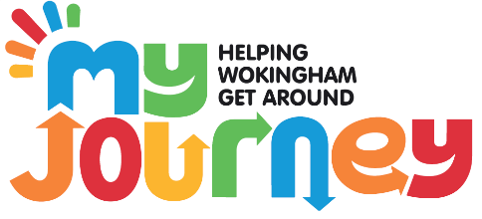

**Learn To Ride Sessions**

Do you need help learning to Ride a pedal bike?

The My Journey Team at Wokingham Borough Council run weekly training sessions for all children aged 5 or above (or aged 4 is attending primary school full time).

The sessions take place at:

**Finchampstead Baptiste Church on Wednesdays at 4-5pm**

And

**Woodford Park on Thursdays at 4-5pm**

All session will need to be booked from our Events page: <https://www.myjourneywokingham.com/events/>

In these sessions, children learn to balance first on Balance Bikes, then are taught by our dedicated team of instructors how to use a pedal bike. Generally, most children will be riding within 2 sessions.

These sessions really help, here’s some wonderful feedback we have received:

“*My daughter attended the class at Finchampstead. Firstly I’d like to say how welcoming and helpful the team at my journey were. They put my daughter at ease, as she was anxious about trying to ride her bike without stabilisers. Within the first 30min she was moved from being on a balance bike to riding her bike using the pedals. I can’t believe how quickly she learnt to ride her bike. Her confidence went from 0-100%. Also I’d like to say it was nice to see the sessions are personalised for each child. The my journey team worked with the children on a 1-2-1 basis as well as a group. They looked at their weaknesses and gave them the confidence to work on them. I would highly recommend my journey. My journey recommends 2 sessions, my daughter learnt how to ride within the hour. Thank you my journey!!”*